**HVAC MODEL DESIGNER**

A PROGRAM TO ASSIST IN HVAC DESIGNING

Table of Contents

1 INTRODUCTION 3

1.1 Purpose and Scope 3

1.2 Organization 3

1.3 Point of Contact 3

2 Modes 4

2.1 WALL EDITOR - Create 4

2.2 WALL EDITOR – Edit Point 6

2.3 VIEW – Drag 2D 7

2.4 VIEW – Rotate 2D 8

2.5 VIEW – View 3D 9

2.6 Simulator 14

Not Added (yet):

Modes

* 1. Project Editor
  2. Wall Editor
     1. Edit Corner
     2. Delete
  3. Room Editor
  4. Floor Picker
  5. Zoom

# INTRODUCTION

Are you thinking about designing your own HVAC system to better heat and cool your home or business? Do you want to avoid paying a contractor hundreds (if not thousands) of dollars? Then this software is for you! Allow us to introduce the HVAC Model Designer, a program that will allow you to draw your building, input some data, and obtain an accurate estimation for where heating and cooling units should be installed.

## Purpose and Scope

This manual is intended to instruct in the use of the HVAC Model Designer software program created by Matthew French, Austin Elliott, and AJ Massey. It is not intended to be used with any other software designed. Ever.

## Organization

This manual will be divided into sections that detail how each function works. Within each function, there may be sub-functions that will be explained. All functions will include illustrations to better assist those that just like to see pictures instead of reading the manual.

## Point of Contact

If you have any questions, comments, or concerns about this software, please contact Nathan Bean by bombarding him with emails at: [nhbean@ksu.edu](mailto:nhbean@ksu.edu) or by calling his office several times at: (785) 532-7768 or by stalking his office at: 2216 Engineering Hall.

# Modes

## WALL EDITOR - Create

In the **HVAC Model Designer**, you will be able to create floor plans for every floor in your building. To better assist in doing that, the **HVAC Model Designer** allows the user to create wall structures that store data about windows and doors. The **HVAC Model Designer** starts in **Wall Editor Mode** by default. From here, you can create walls by clicking **Wall Editor -> Create Wall** in the application menu.  
  
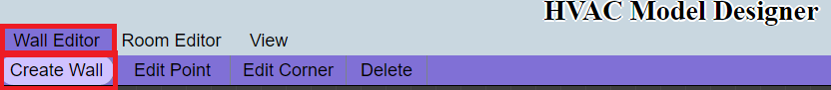  
  
 Once you have done that, you will be able to begin drawing lines on the canvas provided below. These lines will, as you draw, show you the both the perpendicular guideline and the collinear guidelinefor that line. In addition, if you have other lines drawn, you will see the perpendicular and collinear guidelines for the nearest point to the line you are currently drawing.  
  
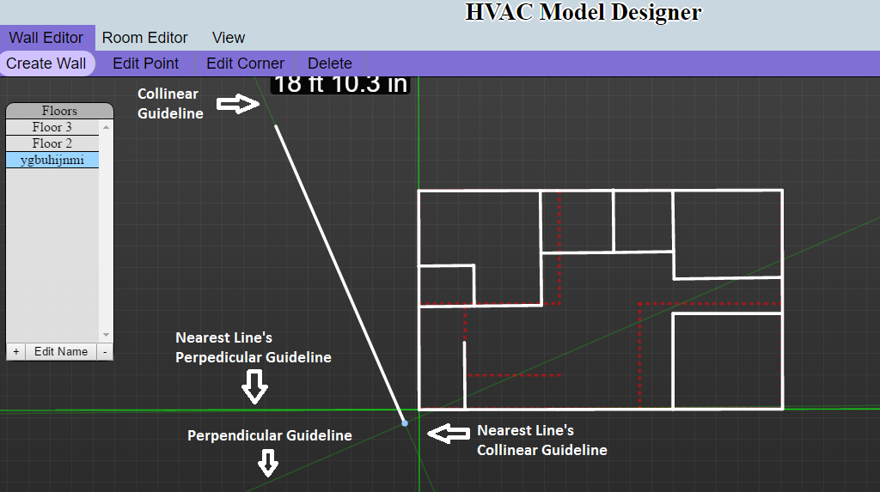

## WALL EDITOR – Edit Point

After you have created some walls, you can edit where the endpoints of those walls are located. By clicking **Wall Editor -> Edit Point**.

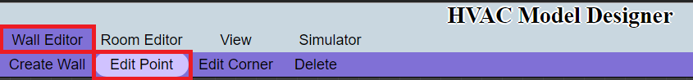

To edit a point, find the point you wish to edit. Then click and move the point to where you wish it to be.  
  
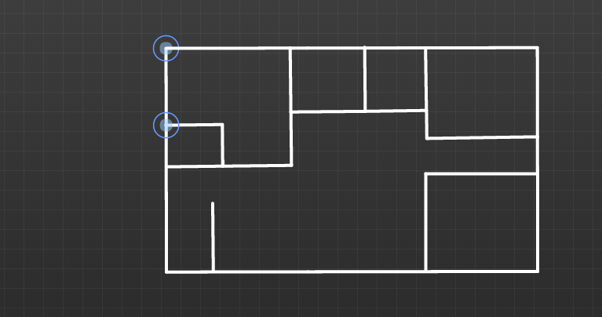

After moving the point to the left:

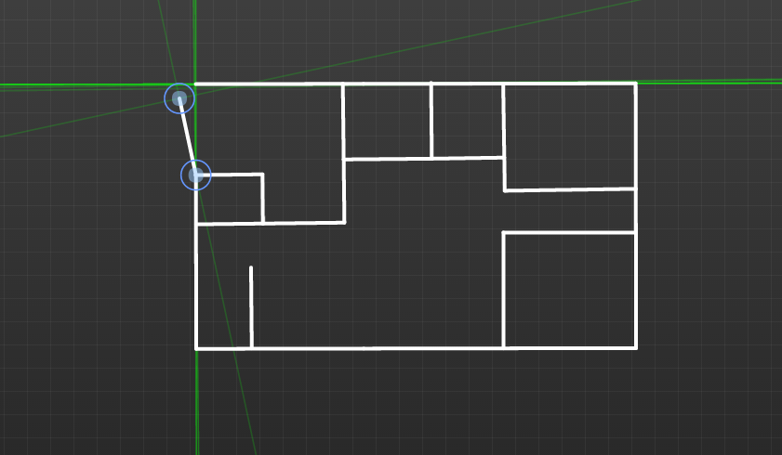

## VIEW – Drag 2D

To use the **Drag** function, you will click **View -> Drag 2D**. The **Drag** option will allow you to drag the canvas behind the created structures, enabling you to see different sections of the structure.

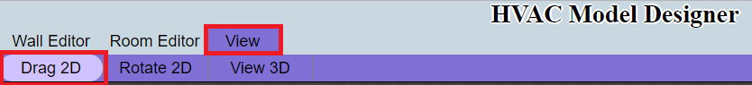

To drag the canvas, click anywhere on the canvas and then slide your mouse in the opposite direction you wish to move.

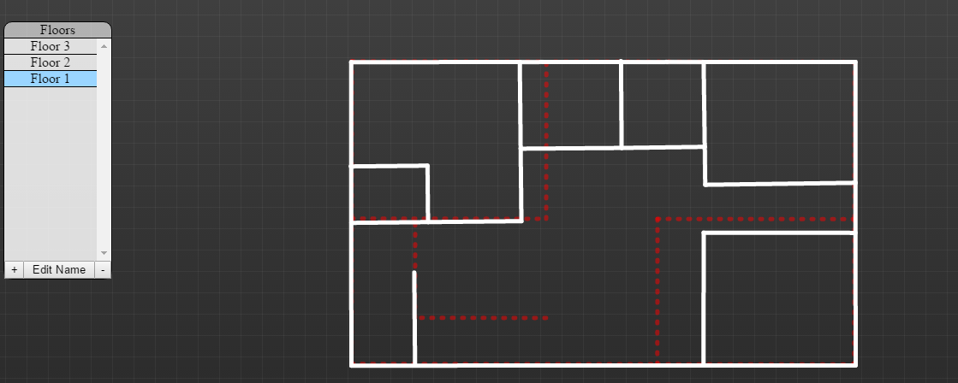

After clicking and moving the mouse to the left:

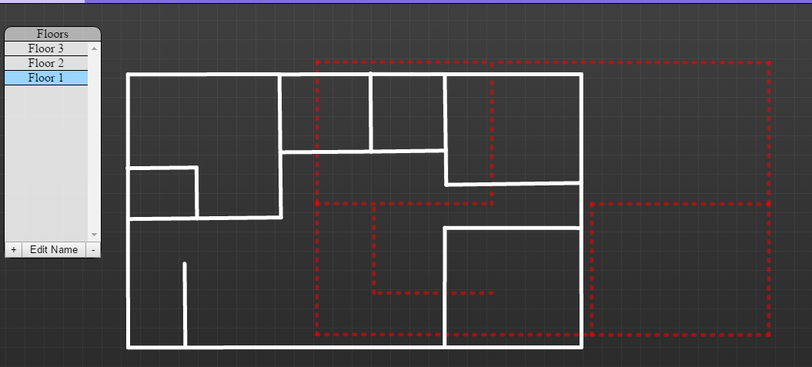

## VIEW – Rotate 2D

To use the **Rotate 2D** function, you will click **View -> Rotate 2D**. The **Rotate 2D** option will allow you to rotate the structure, enabling you to see the structure from different angles.

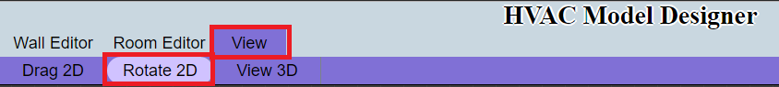

To rotate the structure, click anywhere on the canvas and then move your mouse in the direction you wish to rotate the structure.

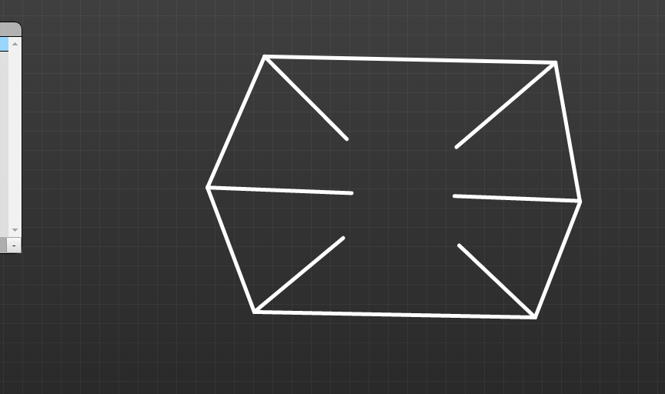

After clicking and moving the mouse to the right:

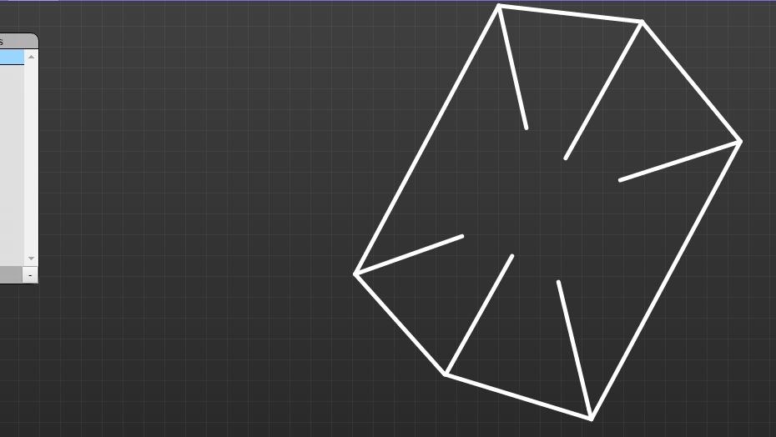

## VIEW – View 3D

To use the **View 3D** function, you will click **View -> View 3D**. The **View 3D** option will build 3D objects on top of the structure you have created, enabling you to see the structure from a 3D perspective.

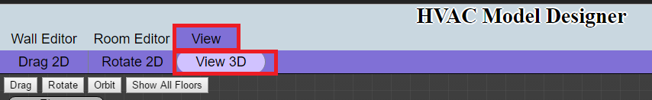

Once in **3D Mode**, more options will be made available to you. The first is the **3D Drag** option.

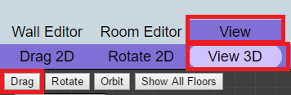

**3D Mode** starts off in the **3D Drag** option, but you can also select this option by clicking **View -> 3D -> Drag**. When **3D Drag** is selected, you will be able to move the structure by clicking anywhere on the canvas and moving the mouse in the direction you want to move the structure.

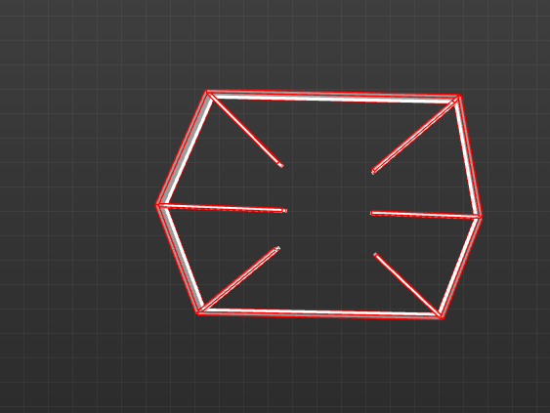

After clicking and moving the mouse to the left:

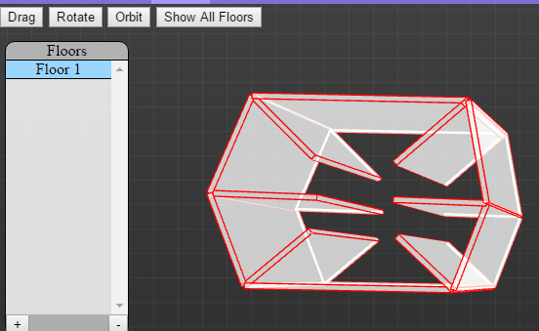

The next 3D option is Rotate. This option will allow you to rotate the 3D structure to see the structure from different angles. To use the **3D Rotate** option, click **View -> View 3D -> Rotate**.

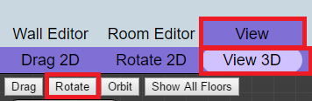

When **3D Rotate** is selected, you will be able to click anywhere on the canvas and rotate the 3D structure in the direction you move your mouse.



After clicking on the canvas and moving the mouse to the left:

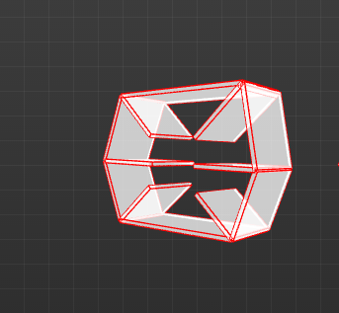

The next 3D option is Orbit. This option will allow you to orbit the 3D structure on one axis. To use the **3D Orbit** option, click **View -> View 3D -> Orbit**.

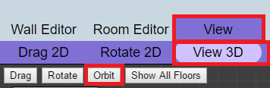

When **3D Orbit** is selected, you will be able to click anywhere on the canvas and move your mouse left and right to see the image orbit on a single plane.

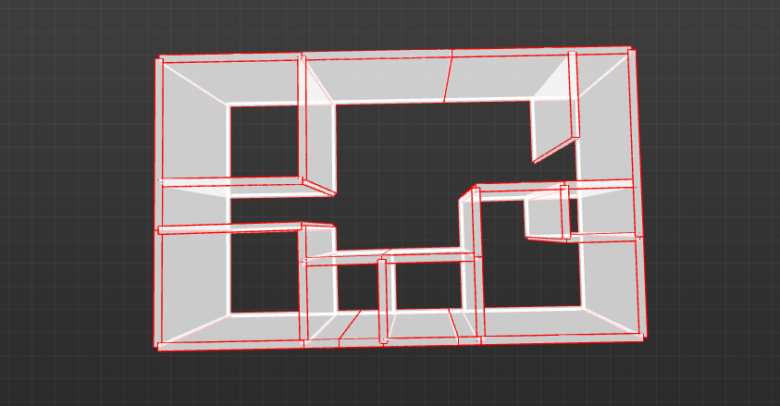

After clicking on the canvas and moving the mouse to the left:

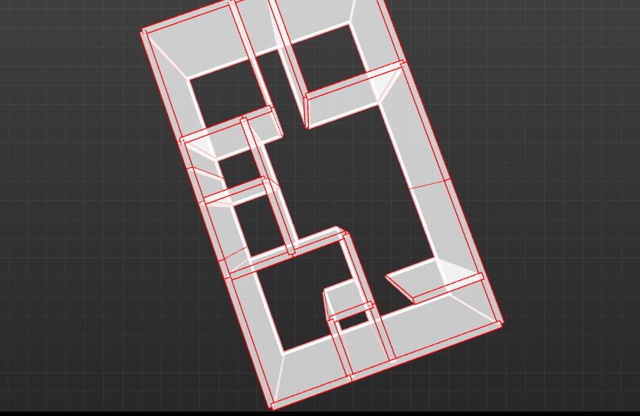

The last 3D option is **Show All Floors**. This option will build all floor plans using 3D objects to show the entire building. To use the **Show All Floors** option, click **View -> View 3D -> Show All Floors**.

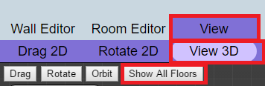

You will know that you are viewing all floors when your canvas shows an image like the one below:

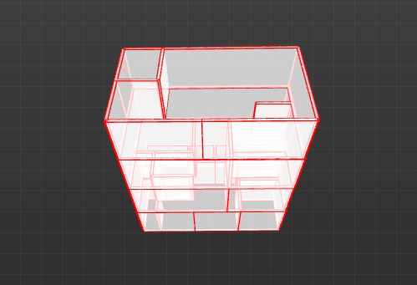

## SIMULATOR

The simulator’s purpose is to generate a visualization of heat movement in the designed room.

### Understanding the Simulator

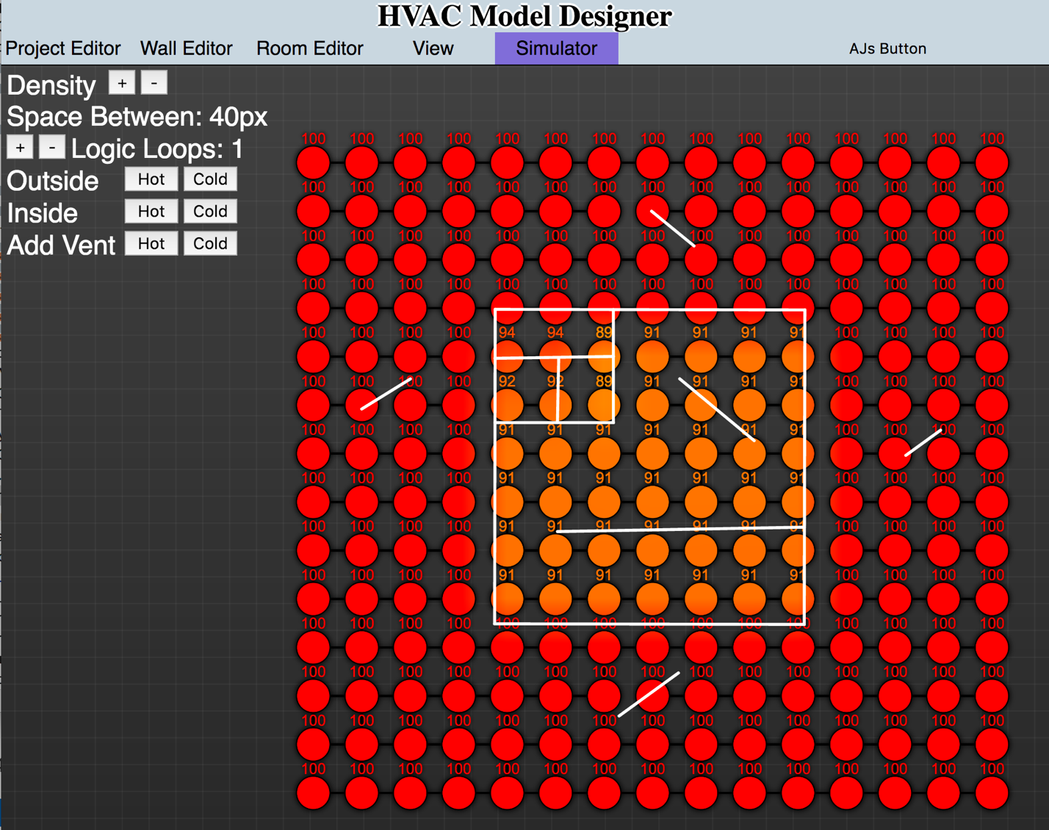

The simulator may seem daunting and complicated, it is a bit more advanced than the previous systems- but for good reason.

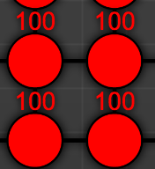

These are air pockets. The color and text they display is their current temperature. Heat transfer will show as fluctuation in temperature. Heat transfer happens between all air pockets that are next to each other. If a wall is between two air pockets, the heat transfer is decreased to the transfer value of the wall.

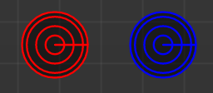

There are two vents as shown above. Hot vent and cold vent. Hot produces heat while the cold vent produces the temperature of your ex’s heart. Vents can be moved with the mouse and deleted with a right click.

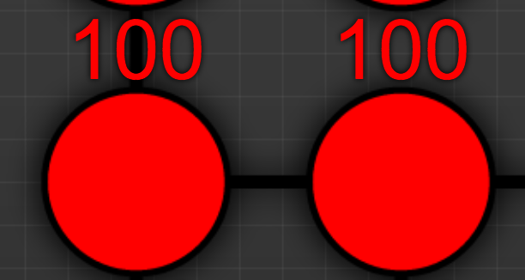

The line between air pockets shows the relationship- that there is no wall keeping them apart. No obstacle that can stop their love- ahem, heat transfer.

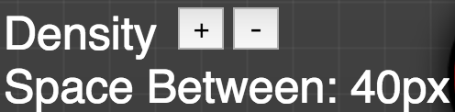

Density and space between are inverse. The greater the density, the smaller the space between air pockets. A smaller space between air pockets(greater density) produces a more accurate simulation. As you increase the density, you will notice the air pockets get smaller and closer together.

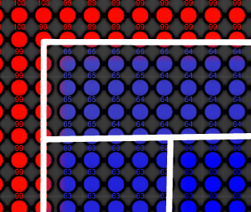

Space between has been reduced to 10px. The air pockets are much closer together. If only it were that easy for people to become closer.

../../../Desktop/Screen%20Shot%202017-04-13%20at%2011.06.26%2

Logic loops is the number of loops the logic does per millisecond. The greater the logic loops, the faster the simulation will run. Be careful, computer processing increases as the logic loops increase.

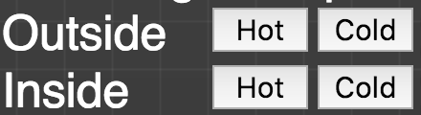

These buttons control the ambient external temperature and the indoor temperature. For example, simulating summer and winter with heat loss and cooling loss.

../../../Desktop/Screen%20Shot%202017-04-13%20at%2011.09.28%2

The vents shown previously are added through these buttons. You can add a vent that produces maximum heat or a vent that produces maximum anti-heat.

### When to use the simulator

The simulator is to be used when the intended goal is to find out how much heat is seeping out of the designed room and where the most appropriate places for vents should be. Or you can just use the simulator because it’s really fun to play with. You do you.